EARTH AND SPACE SCIENCES
SECOND HAND DATA ANALYSIS – GREENHOUSE EFFECT

Time Allowed: 40 minutes

Name: _________________________________ Mark: __________/20

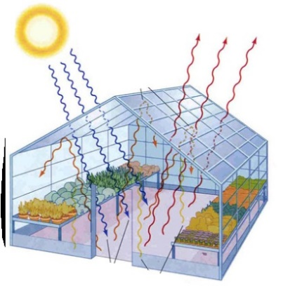
A student investigated the effect of the concentration of carbon dioxide on the temperature produced in a glass greenhouse. He used a garden greenhouse and measured the initial concentration of CO₂ and the temperature. Each morning, he increased the concentration of CO₂ (using bottled carbon dioxide) then recorded the temperature within the greenhouse at 4pm.

- Write a hypothesis for this student’s investigation.
(2 marks)

- Relate temperature in greenhouse and carbon dioxide concentration
- Explicit testable 3rd person statement
- E.g. The higher the concentration of CO₂ in the greenhouse the higher the temperature within the greenhouse

- Identify the dependent variable in this investigation.
(1 mark)

Temperature within the greenhouse

- Identify the independent variable in this investigation.
(1 mark)

Concentration of carbon dioxide gas added to greenhouse

- State two variables that the student controlled in his investigation.
(2 marks)
- Time of day temperature was measured
- Volume/size of the greenhouse
- Colour/type of greenhouse glass

The following data was collected by the student.
Concentration of CO₂  (mg/L) | 10 | 15 | 20 | 30 | 40 | 50 | 65 | 80
Temperature inside the greenhouse  (ºC) | 25 | 31 | 36 | 43 | 48 | 49 | 54 | 55

- Draw an appropriate graph of this data with a line (curve) of best fit.
(6 marks)
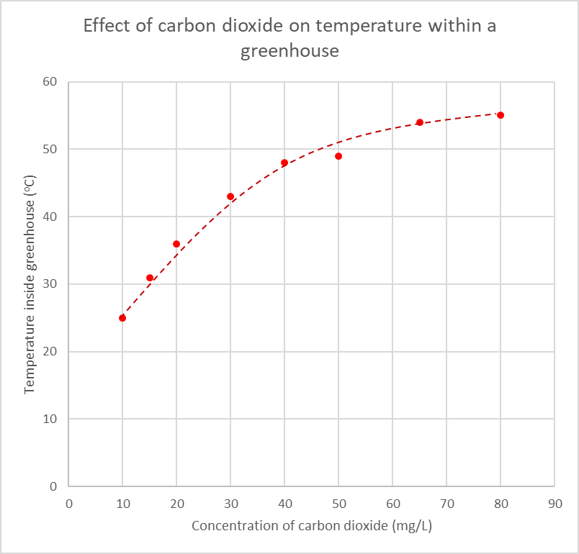
Minus 1 mark for each wrong/missing (max 6)
- Appropriate title
- Correctly labelled axes / Units on axes
- Independent variable on horizontal axis
- Appropriate scale
- Correctly plotted points
- Smooth curve of best fit
- Describe the relationship between the independent and dependent variables of this experiment. Be specific by referring to data from your graph.
(2 marks)

If student writes something to effect of:

- The temperature in the greenhouse increases as the concentration of CO₂ increases – 1 mark

- The temperature in the greenhouse increases at a decreasing rate as the concentration of CO₂ increases – 2 marks

Note that the students haven’t been taught “increasing at a decreasing rate” in maths. Accept terms similar to this:
“as the temperature rose, larger increases in CO₂ concentration were required to increase the temperature of the greenhouse further”
“initially the temperature increases a lot but as more CO₂ is added, the temperature of the greenhouse rises less and less”
“the temperature rose until a point when it stopped increasing as much as CO2 was added, resulting in the points getting closer together as if it has reached a temperature limit”

- Does the description you wrote for question 6 support or not support the hypothesis you wrote in question 1? Circle your choice below and explain your reasoning.
(1 mark)
Support / Does Not Support
Will depend on student’s previous answers –

To get mark students’ justification for support/refute must relate to hypothesis in Question 1 and the relationship shown in the graph

- The students’ teacher told him that the investigation was not valid (a fair test).
  - What is a fair test?
(1 mark)

- Adequately tests the required variable whilst controlling all other variables likely to affect the outcome of the investigation

  - State one major error in the student’s investigation and explain why it makes the investigation invalid. (2 marks)

1 mark - stating major error
1 mark - explaining why investigation invalid
- Give followthrough for the 2nd mark if they explain how their chosen flaw means the test is invalid

Either:

- External temperature not taken into account (hot day vs cold day) therefore the temperature within greenhouse could therefore be a result of outside temperature influences

Or:

- Same amount of sunlight can not be guaranteed (cloud cover, rain etc) thus the temperature within the greenhouse could be compromised.

  - Suggest one way the student could alter the investigation to overcome the major error you outlined in 8b and how it overcomes the error.
(2 marks)
1 mark – relevant suggestion
1 mark – explains how it overcomes flaw
Students’ answers need to be explicit and detailed.
Give follow-through marks if the suggestion is reasonable, addresses the error and is explained clearly (even if the error isn’t correct).

For example:

- Rather than use a greenhouse, student could simulate the investigation within laboratory conditions using a container of known volume and a heat lamp. This ensures the conditions are kept the same.

- Student could record the external temperature and compare change in temperature between inside and outside of greenhouse to the concentration of CO₂. This accounts for temperature differences each day.

- Use a control. One greenhouse next to the other greenhouse that has no CO2 added to it. This would then prove whether or not the CO₂ is the variable influencing the temperature within the greenhouse.

